Name: _____________________ PS ID# ___ COSC 3380

Exam 4

1. (10 pts)

Consider the following Schedule:
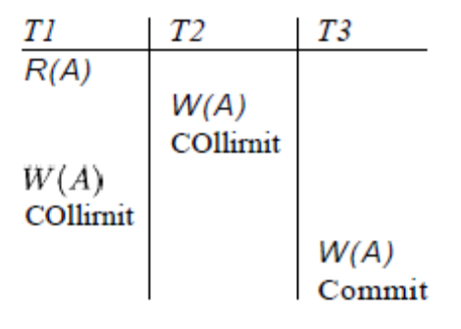
Commit
Commit

Determine whether the schedule is Conflict Serializable.
Draw the Dependency Graph.
If the answer is NO, please justify why.

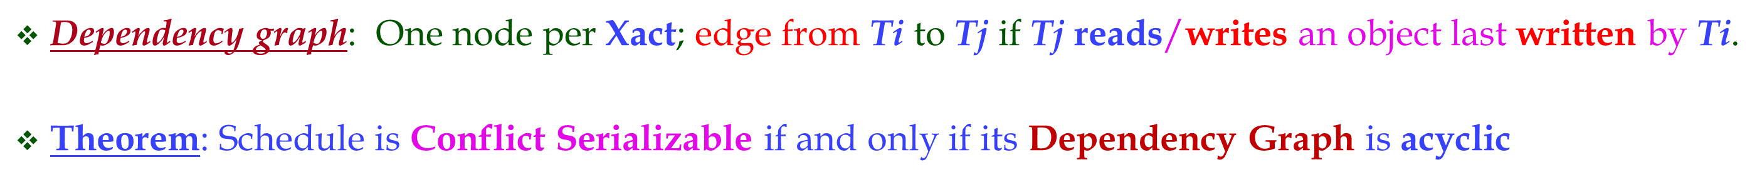

ANSWER:

2. (10 pts)

Consider the following Schedule:
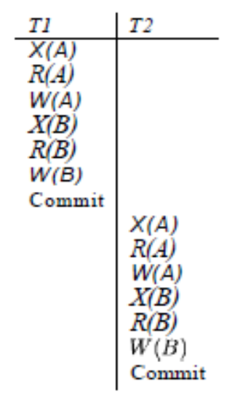

Is this schedule Conflict Serializable?
Draw the Dependency graph.
If the answer is NO, please justify why.

ANSWER:

3. (10 pts)

State if this following Schedule is Conflict Serializable.
Draw the Dependency graph.
If the answer is NO, please justify why.

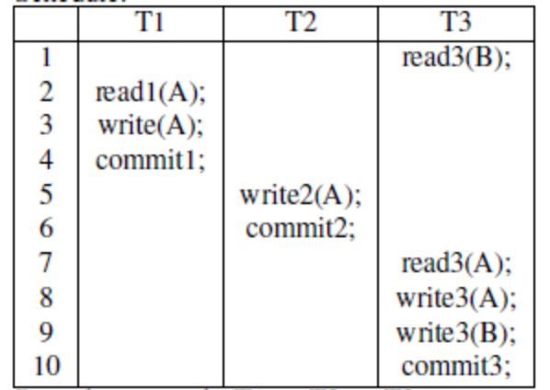

ANSWER:

4. (10 pts)

Determine whether this Schedule is Serializable. Please draw the Serializability Graph.

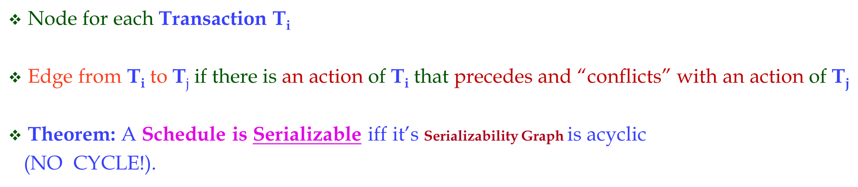

S = [R1(Z), R2(Y), W2(Y), R3(Y), R1(X), W1(X), W1(Z), W3(Y), R2(X), R1(Y), W1(Y),W2(X), R3(Z), W3(Z)]

where Ri(Z)/Wi(Z) indicates a read/write by transaction i on data item Z.

(NOTE: Please create a TABLE format for this Schedule with the columns being the Transactions and the Rows being the Schedule (only one action per Row). Then draw the edges on this TABLE before building the Serializability Graph)
ANSWER:
5. (10 pts)
Determine whether this Schedule is Serializable. Please draw the Serializability Graph.

S = [R₁(Z), W₂(X), R₂(Z), R₂(Y), W₁(X), W₃(Z), W₁(Y), R₃(X)]

where Ri(Z)/Wi(Z) indicates a read/write by transaction i on data item Z.

(NOTE: Please create a TABLE format for this Schedule with the columns being the Transactions and the Rows being the Schedule (only one action per Row). Then draw the edges on this TABLE before building the Serializability Graph)

ANSWER:

6. (10 pts)

Consider the following sequence of actions, listed in the order they are submitted to the DBMS. Assume Strict 2PL with Deadlock Detection.
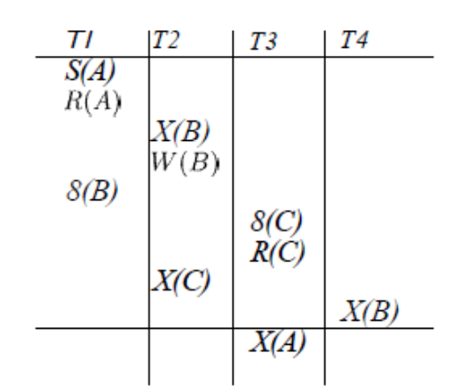
S(B)
S(C)

Draw the Wait For Graph (WFG) for the transactions and determine whether deadlock exists.

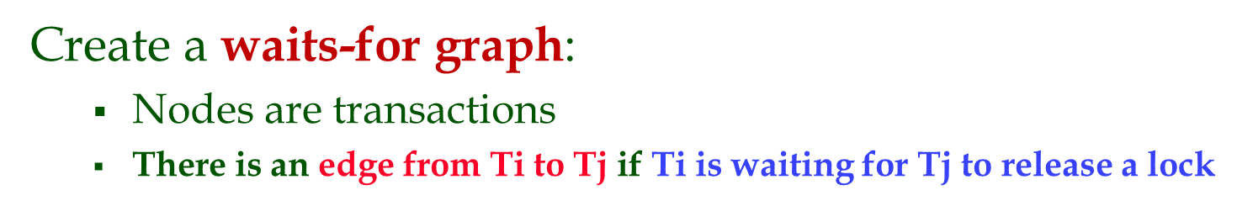

ANSWER:

7. (15 pts)
Consider the execution shown below.
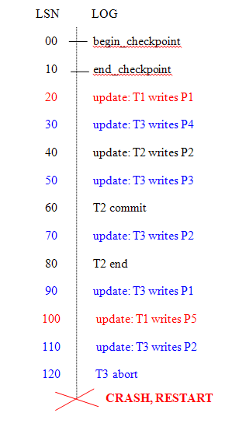

a. (5 pts) Extend the figure to show prevLSN and undonextLSN values.

LSN | Type | prevLSN | undonextLSN
00
10
20
30
40
50
60
70
80
90
100
110
120

b. (5 pts) Describe the actions taken to rollback transaction T 3.

ANSWER:

c. (5 pts) Show the log after the CRASH, RESTART, including all prevLSN and undonextLSN values in log records.

LSN | Trans ID | nextLSN | prevLSN | Type | Page ID | undonextLSN
8. (25 pts)

Consider the Employee(ENAME, DEPT, SALARY) below:

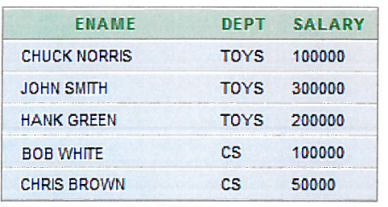

For authorization purposes you also define Views EmployeeNames (with ENAME as the only attribute) and DeptInfo with fields DEPT and AVGSALARY. The latter lists the average salary for each department.

a. (5 pts) Show the View definition statements for EmployeeName and DeptInfo.

ANSWER:

b. (5 pts) Show contents of Views EmployeeName and DeptInfo.

ANSWER:

c. (5 pt) What privileges should be granted to a user who needs to know only average department salaries for the Toy and CS departments?

ANSWER:

d. (5 pts) You are to authorize your secretary to fire people (you will probably tell him whom to fire, but you want to be able to delegate this task),

ANSWER:

e. (5 pt) Assume existence of user Assistant Manager assistant.
What privilege should you grant to assistant who needs to know only average department salaries? Express it in proper SQL.

ANSWER:

